**Problem Statement:**

* Top 5 customers by customers and sales quantity
* 2 Weakest region where sales are declining – Revenue breakdown by cities – so we add extra discount at that places
* Aggregate revenue in last 365 days - Revenue breakdown by month and year
* Top 5 product by revenue number

**Aims grid**

The Aim's Grid is **a central tool for planning any venture and a must-have for project leaders**. This tool helps you collect the most important information about your project on one simple page, laying the foundation for a successful implementation.

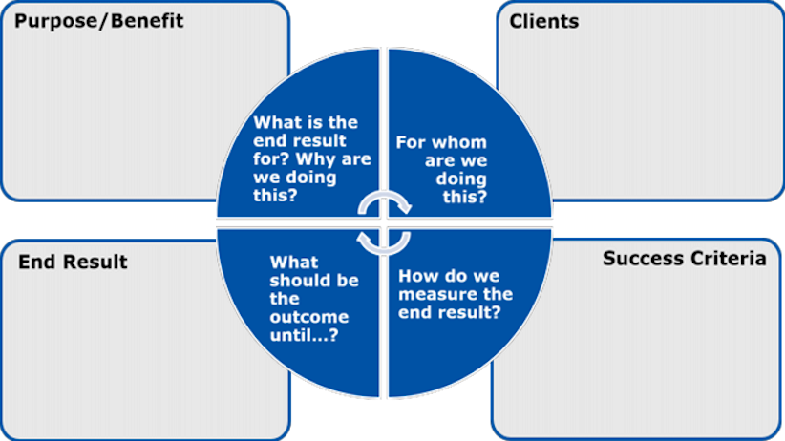

**PURPOSE**

To unlock sales insights that are not visible before for sales team for decision support & automate them to reduced manual time spent in data gathering.

**STAKEHOLDERS/Clients**

* Sales Director
* Marketing Team
* Customer Service Team
* Data & Analytics Team
* IT

**END RESULT**

An automated dashboard is providing quick & latest sales insights in order to support data driven decision making.

**SUCCESS CRITERIA**

* Dashboard(s) uncovering sales order insights with latest data available
* Sales team able to take better decisions & prove 10% cost savings of total spend
* Sales Analysts stop data gathering manually in order to save 20% of their business time and reinvest it value added activity

**Whole ETL Process:** 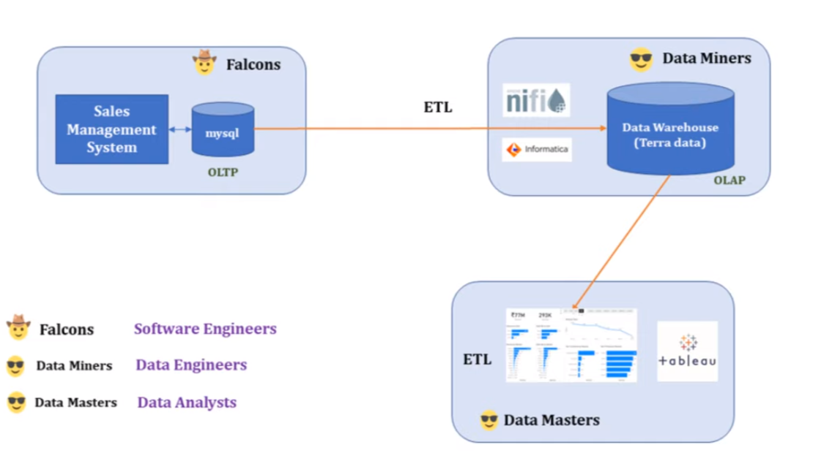

**Data Exploration in SQL**

* Top 5 customers by customers and sales quantity

SELECT c.custmer_name,SUM(t.sales_qty) as Total_purchased FROM transactions t JOIN customers c ON c.customer_code=t.customer_code GROUP BY t.customer_code ORDER BY Total_purchased DESC LIMIT 5

* 2 Weakest region where sales are declining – Revenue breakdown by cities

UPDATE transactions SET sales_amount=sales_amount*80.20 WHERE currency LIKE "USD"

UPDATE transactions SET currency="INR" WHERE currency="USD" ;

SELECT m.markets_name,SUM(t.sales_amount) AS revenue FROM transactions t JOIN markets m ON m.markets_code=t.market_code GROUP BY t.market_code ORDER BY revenue LIMIT 2;

* Aggregate revenue in last 365 days - Revenue breakdown by month and year

SELECT YEAR(order_date),MONTHNAME(order_date),SUM(sales_amount) FROM transactions GROUP BY YEAR(order_date),MONTHNAME(order_date) ORDER BY YEAR(order_date),MONTH(order_date);

* Top 5 product by revenue number

SELECT product_code,SUM(sales_amount) AS Revenue FROM transactions GROUP BY product_code ORDER BY Revenue DESC LIMIT 5

**Dashboard 1**

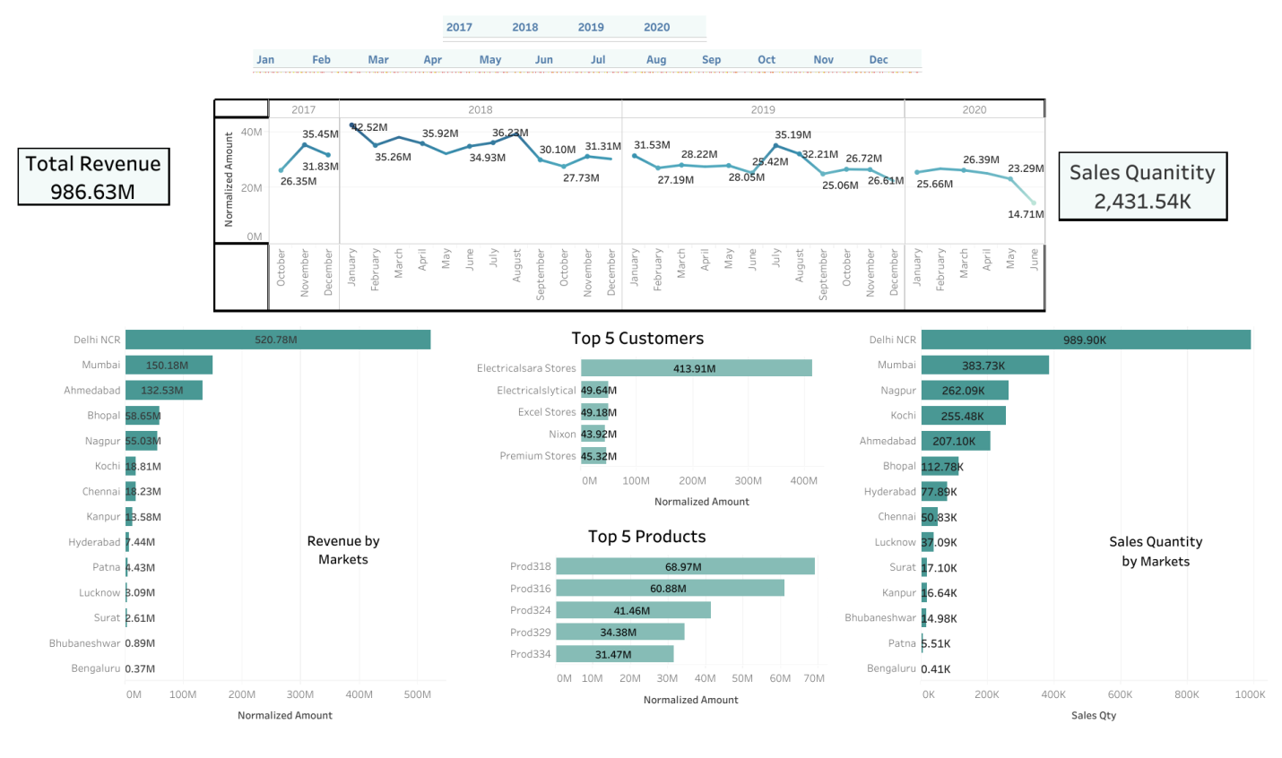

**Fault1:**

If are applying multiple filtering, use context filter as well – o/w don’t get full data

**Context filter:** **You can think of a context filter as being an independent filter**. Any other filters you set are dependent filters because they process only the data that passes through the context filter. == We generally use it in multiple filtering

**Revised Dashboard**

